**What is Derived Attribute in DBMS?**

A derived attribute is an attribute or property in a table that has been calculated or derived using other attributes in the **database**. The data of a derived attribute is derived or copied from the attributes of another table lying in the same database. They don't exist physically in the database.

**1. Total Participation-**

1. It specifies that each entity in the entity set must compulsorily participate in at least one relationship instance in that relationship set.That is why, it is also called as mandatory participation.
2. Total participation is represented using a double line between the entity set and relationship set.

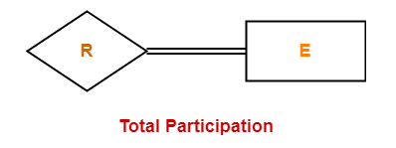

Example-

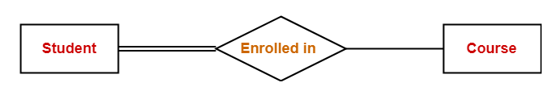

Here,

Double line between the entity set “Student” and relationship set “Enrolled in” signifies total participation. It specifies that each student must be enrolled in at least one course.

**2. Partial Participation-**

1. It specifies that each entity in the entity set may or may not participate in the relationship instance in that relationship set. That is why, it is also called as optional participation.
2. Partial participation is represented using a single line between the entity set and relationship set.

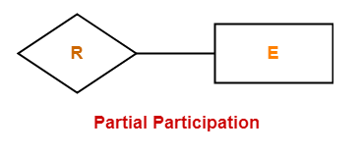

Example-

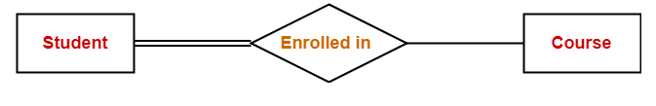

Here,

Single line between the entity set “Course” and relationship set “Enrolled in” signifies partial participation. It specifies that there might exist some courses for which no enrollments are made.